Rain WATER Harvesting

Developer Guide

|  |  |  |
| --- | --- | --- |
| **Supervisor:** | Sir Muhammad Haris |  |
| **Batch:** | 2401F2 |  |
| **Group:** | D |  |
| **Serial no.** | **Enrollment number** | **Student Name** |
| 1. | 1547317 | Faiq ashfaque |
| 2. | 1545845 | Abdullah ghfoor |
| 3. | 1546846 | Bilal khan |
|  |  |  |



Home (index.html)

Figure 1: Home Page For Our rain Water Harvesting Website:

Our Slogan has given to the peoples toward our website. “Rain Water Harvesting”.

* OUR HOME PAGE WELCOMES OUR CUSTUMERS WITH BEAUTIFUL QOUTE.

Code Of Home Page

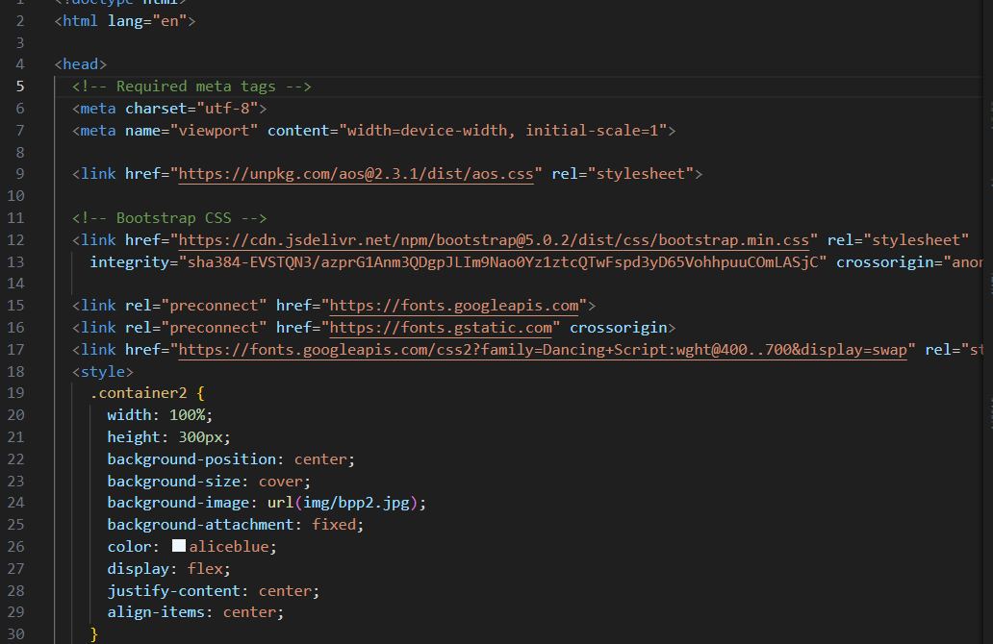

Membership (Index.html)

PAGE OF MEMBER SHIP

Basic and premium

CODE OF MEMBER SHIP

Basic and premium

FOOTER (Index.html):

DESIGN OF FOOTER



CODE OF FOOTER

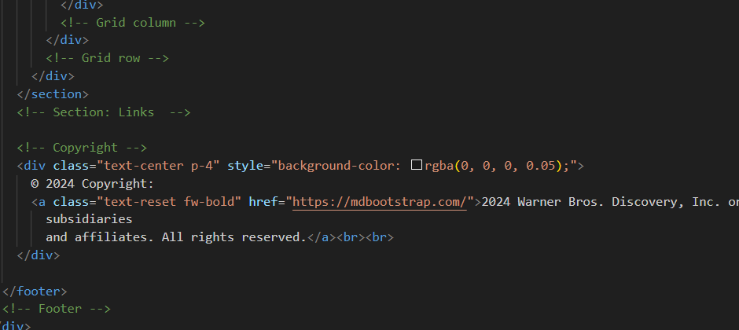

NAVBAR (Index.html):

DESIGN OF NAVBAR



CODE OF NAVBAR

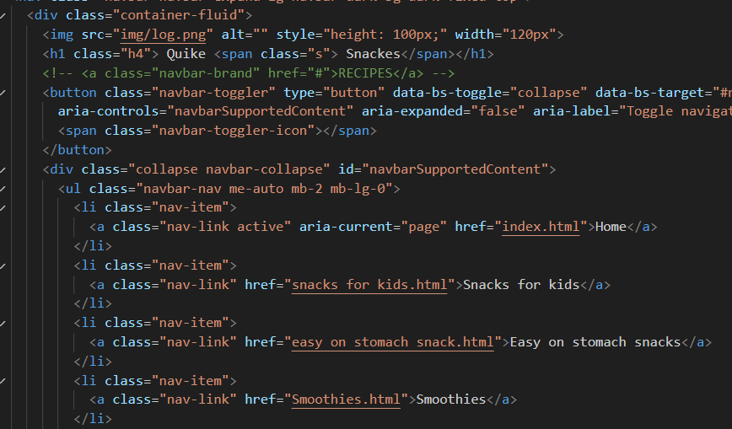

ABOUT US (Index.html):

DESIGN OF ABOUT US

* We have given user an overview of who we are and what our journey is and what we have achieved.

(It’s contain 3 section)

CODE OF ABOUT US

FORM (Index.html):

CODE OF FORM

CONTACT US(Index.html):

DESIGN OF CONTACT US PAGE

Code OF CONTACT US